Experiment: 6
5G NR Frame Structure Analysis with Different Subcarrier Spacing
Aim
To analyze the 5G NR frame structure by studying the effect of different subcarrier spacings, slot durations, and OFDM symbols using MATLAB.
Objectives
- To analyze different Subcarrier Spacing (SCS) values used in 5G NR numerology.
- To compare the slot duration corresponding to different Subcarrier Spacing values in 5G NR.
- To study the number of OFDM symbols present in a 5G NR slot for normal cyclic prefix. Software Required
• MATLAB
Theory
Unlike previous generations of mobile communication, 5G New Radio (NR) employs flexible numerology, where different subcarrier spacings are used depending on the deployment scenario and service requirements. Increasing the subcarrier spacing reduces the slot duration, enabling lower latency and supporting diverse applications such as enhanced Mobile Broadband (eMBB), Ultra-Reliable Low-Latency Communications (URLLC), and massive Machine-Type Communications (mMTC). Regardless of the selected numerology, a normal cyclic prefix slot contains 14 OFDM symbols.
Objective – 1
Analyze the standard subcarrier spacing (SCS) values defined in the 5G NR numerology using MATLAB. Compare the relationship between the numerology index (μ) and subcarrier spacing to understand the flexible bandwidth allocation employed in 5G communication systems.
Procedure
- Define the supported 5G NR subcarrier spacing values.
- Display the values using MATLAB.
- Plot the subcarrier spacing for different numerologies.
Objective – 1: Analyze Different Subcarrier Spacing Values
clc;
clear;
close all;

% Subcarrier Spacing (kHz)
scs = [15 30 60 120 240];

% Numerology Index
mu = 0:4;

% Bar graph
bar(scs);

grid on;

% X-axis settings
set(gca, 'XTick', 1:5);
set(gca, 'XTickLabel', mu);

% Labels and title
xlabel('Numerology Index (\mu)');
ylabel('Subcarrier Spacing (kHz)');
title('192512102 5G NR Subcarrier Spacing for Different Numerologies');

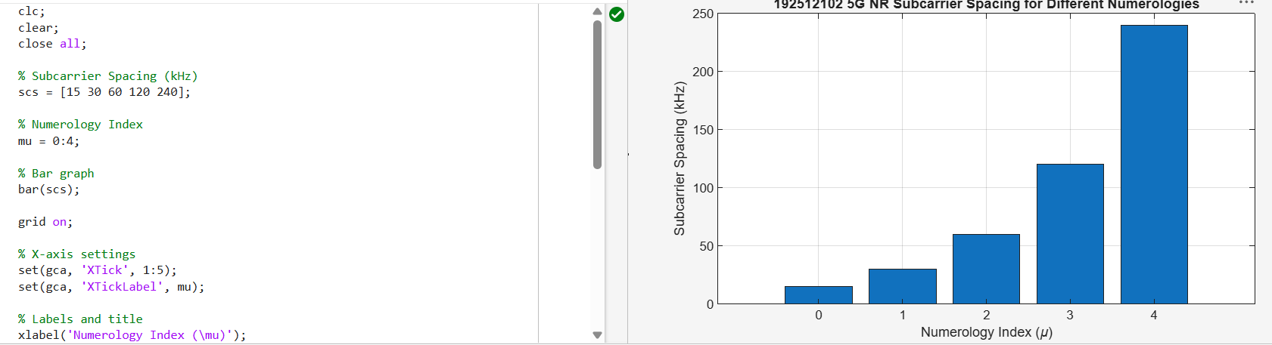
Objective – 2 Compare Slot Duration
Analyze the variation in slot duration corresponding to different 5G NR subcarrier spacing values using MATLAB. Compare the inverse relationship between subcarrier spacing and slot duration to understand how flexible numerology enables low-latency communication in 5G networks.
Procedure
- Define the slot duration corresponding to each subcarrier spacing.
- Plot slot duration versus subcarrier spacing.
- Observe the inverse relationship.
clc;
clear;
close all;

% Subcarrier Spacing (kHz)
scs = [15 30 60 120 240];

% Slot Duration (ms)
slot = [1 0.5 0.25 0.125 0.0625];

% Plot
plot(scs, slot, 'o-', 'LineWidth', 2);

grid on;

% Labels and title
xlabel('Subcarrier Spacing (kHz)');
ylabel('Slot Duration (ms)');
title('192512102 5G NR Slot Duration for Different Subcarrier Spacing');

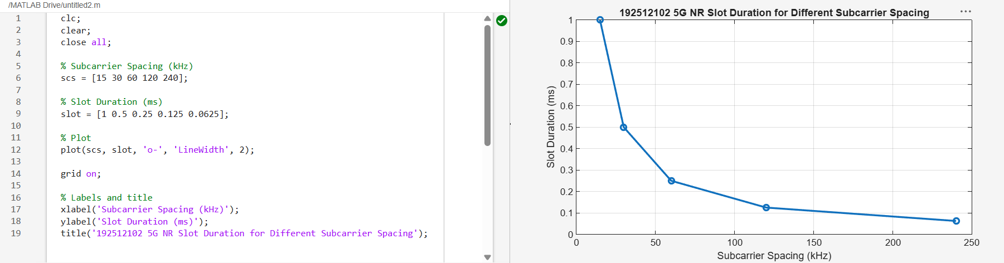
Objective – 3 Study the Number of OFDM Symbols
Analyze the number of OFDM symbols present in a 5G NR slot for different numerology configurations using MATLAB. Observe that, under the normal cyclic prefix, each slot consistently contains 14 OFDM symbols irrespective of the subcarrier spacing.
Procedure
- Define the number of OFDM symbols in a slot.
- Plot the OFDM symbols for different numerologies.
- Observe that the number of symbols remains constant.
clc;
clear;
close all;

% Subcarrier Spacing (kHz)
scs = [15 30 60 120 240];

% OFDM Symbols per Slot
symbols = [14 14 14 14 14];

figure;

% Bar graph
bar(scs, symbols);

grid on;

% Labels and title
xlabel('Subcarrier Spacing (kHz)');
ylabel('Number of OFDM Symbols');

title('192512102 OFDM Symbols per Slot for Different Subcarrier Spacing');

% Y-axis limit
ylim([0 16]);

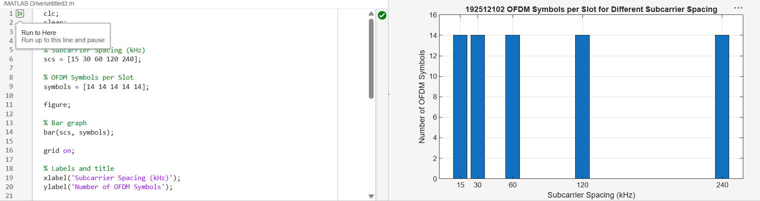
Result
The MATLAB analysis successfully demonstrated the flexible numerology of 5G NR. The results showed that increasing the subcarrier spacing decreases the slot duration while maintaining a constant number of OFDM symbols per slot under the normal cyclic prefix configuration.
Discussion
The 5G NR frame structure is highly flexible and supports multiple numerology configurations through different subcarrier spacing values such as 15 kHz, 30 kHz, 60 kHz, 120 kHz, and 240 kHz. This flexibility allows the system to adapt to a wide range of deployment scenarios, from wide-area coverage to high-capacity low-latency communication.
From the MATLAB analysis, it is observed that as the subcarrier spacing increases, the slot duration decreases proportionally. This inverse relationship ensures that higher subcarrier spacing enables lower latency communication, which is essential for applications like URLLC. However, it also reduces coverage range due to higher sensitivity to Doppler and propagation effects.

